How to use qemu-img-hw

|  |  |  |  |  |  |
| --- | --- | --- | --- | --- | --- |
| No. | Version | Date | Description | Modified By | Document Name |
| 1 | V0.1 | September 26 2023 | Draft version | Armando Ponce Soriano | How to use qemu-image-hw |
| 2 | V0.2 | October 2  2023 | Added an FAQ section and changed Constraints section for Preparation | Armando Ponce Soriano | How to use qemu-img-hw |

# Overview

There are migration scenarios where SMS tasks fail due to complications with the filesystem of our server. In these cases, it is necessary to have the creation of a disk image from external tools such as **qemu-image**. However, if the client requires the image to be in ZVHD or ZVHD2 format we can use the following tool: **qemu-image-hw**.

**qemu-image-hw** is an image converter tool developed by Huawei based on **qemu-img**. Additionally to **qemu-img**, **qemu-img-hw** offers image converting from other formats to RAW or ZVHD/ZVHD2 format.

# Preparation

It is recommended using **CentOS,** or **EulerOS** distributions with the tool. If we use the tool on other distributions, there's the possibility of getting compatibility errors or library errors while execution. More information on FAQ section.

# Validation Steps

1. If you don’t have an image to convert inside your ECS server, upload one to the server via **scp** or third-party tools like **WinSCP**.

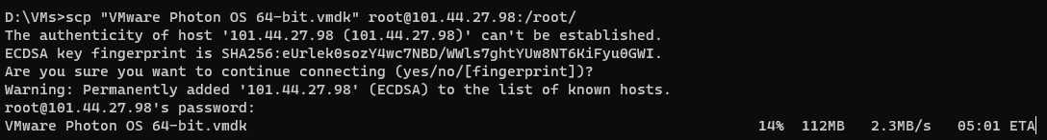

1. Download qemu-image-hw with the following command on your Linux ECS:

wget https://cn-south-1-cloud-reset-pwd.obs.cn-south-1.myhuaweicloud.com/imageImportTools/qemu-img-hw.zip

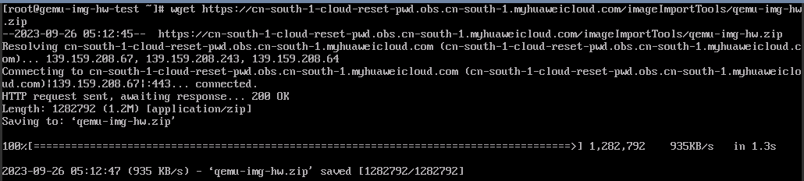

1. Unzip the tool, access the directory where qemu-inage-hw is located and modify the file permissions with the following commands:

**unzip qemu-img-hw.zip**

**cd qemu-img-hw**

**chmod +x qemu-img-hw**

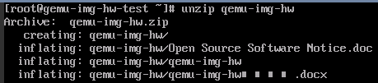

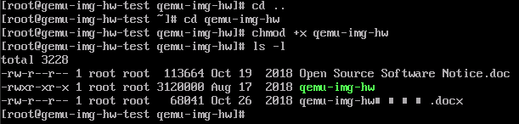

1. Once configurated the permissions, use the following command to convert an image file to VZHD/VZHD2 format:

./qemu-img-hw convert -p <-O Target_image_format> <Source_image_file> <Target_image_file>

**Where**:

* + -p: Indicates the conversion progress.
  + -O: Goes along with the target format, i.e. [-O OUTPUT_FMT].

Use of qemu-img-hw:



Verification:



# FAQ

* **Q**: It is necessary to use qemu-img before using qemu-img-hw?

**A**: No, qemu-img-hw is based on qemu-img, so it has all the capabilities of the base tool, i.e. it is possible to create an image disk of a VM using only qemu-img-hw with the following command:

qemu-img-hw convert -p <-f format> <-O Target_image_format> <Source_image_file> <Target_image_file>

**Where**:

-**f format** is an optional flag, qemu-img-hw will infer the source image format automatically.

Once finished, you can upload your image to HWC to finish the migration task, if you want to know further about this visit the documentation:

[Quickly Importing an Image File (Linux)_Image Management Service_User Guide_Creating a Private Image_Quickly Importing an Image File_Huawei Cloud](https://support.huaweicloud.com/intl/en-us/usermanual-ims/ims_01_0340.html)



The image file has to be optimized before the upload. If you want to know how to optimize your image files follow the HWC user manual related to. You can find it here: [Managing Private Images_Image Management Service_User Guide_Huawei Cloud](https://support.huaweicloud.com/intl/en-us/usermanual-ims/ims_01_0300.html)

* **Q**: About Debian compatibility with qemu-img-hw on HWC.

**A**: On Debian-based distributions we will encounter this error while trying to run the tool.

C:\Users\a50032668\AppData\Local\Microsoft\Windows\Clipboard\HistoryData\{804E0682-C54C-4E6C-9652-74B1B1083BD4}\{64EBCF00-22FA-4C2B-B0F6-72EC6137C7B0}\ResourceMap\{4C200170-DC9B-4AB1-80C7-4369336EAC9B}

If we look for the library we will found that it’s not installed on the system

C:\Users\a50032668\AppData\Local\Microsoft\Windows\Clipboard\HistoryData\{804E0682-C54C-4E6C-9652-74B1B1083BD4}\{64EBCF00-22FA-4C2B-B0F6-72EC6137C7B0}\ResourceMap\{4404125D-91F2-42E2-A816-97C4185A2B22}

For that reason, it is not currently possible to use qemu-img-hw in Debian-based images

# Appendix

If you need more information about common commands of **qemu-img-hw** or errors on execution time, refer to the following documentation:

[Converting the Image Format Using qemu-img-hw_Image Management Service_Best Practices_Converting the Image Format_Huawei Cloud](https://support.huaweicloud.com/intl/en-us/bestpractice-ims/ims_bp_0052.html)